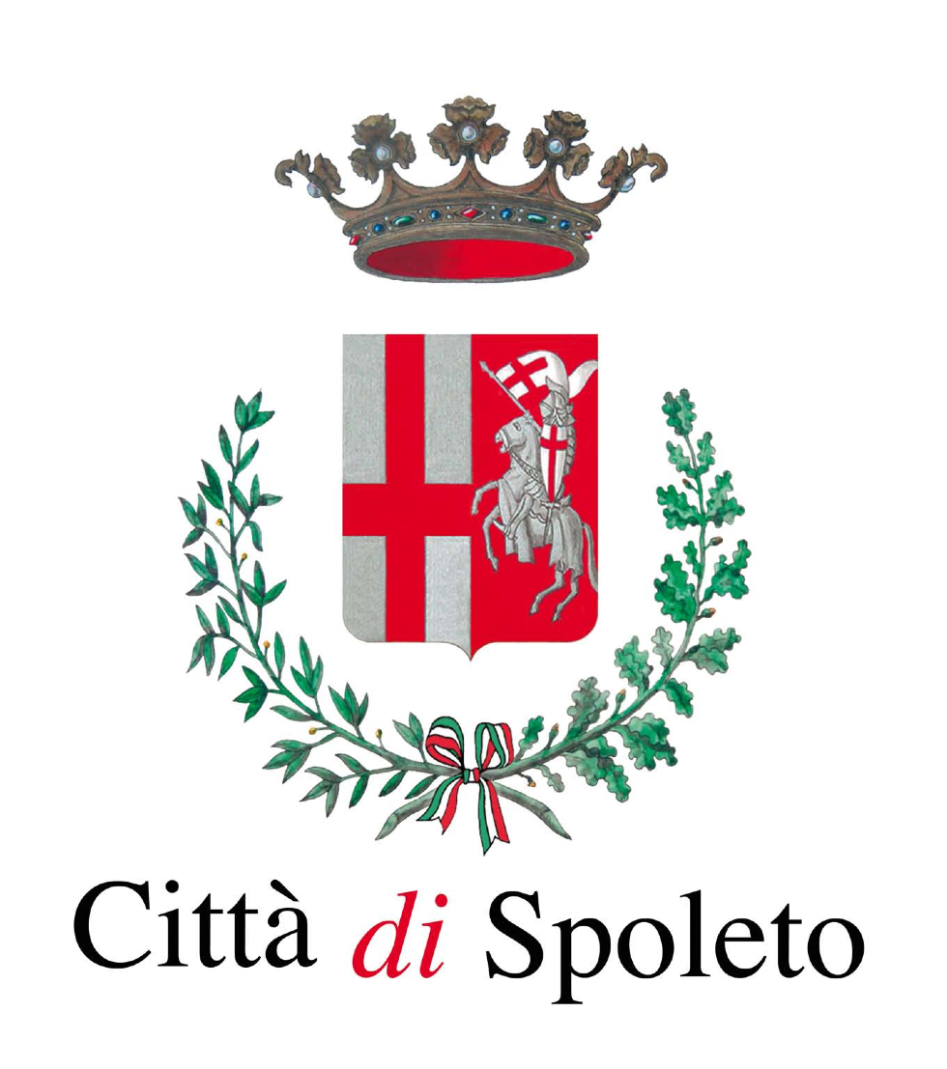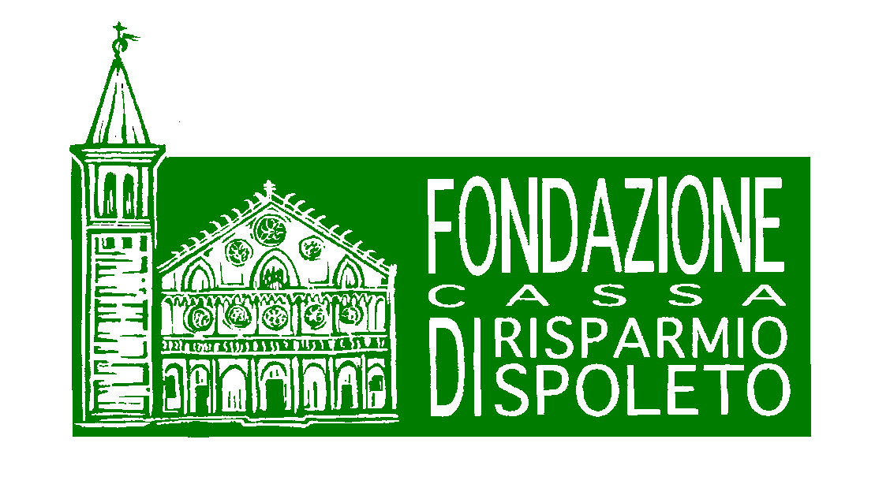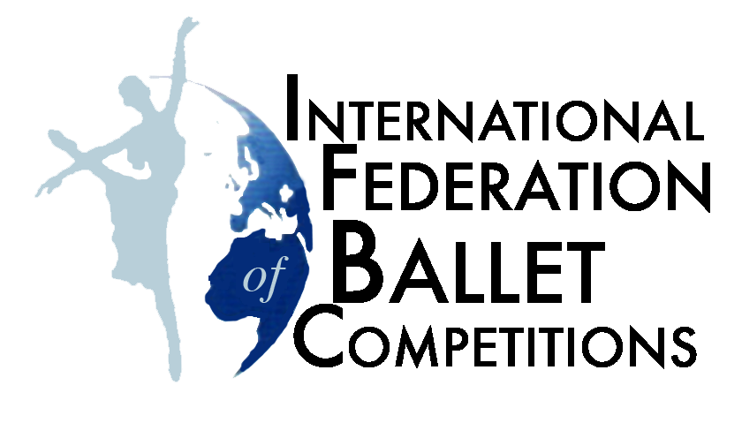



PARENTAL CONSENT FOR MINORS

The undersigned Mr /Mrs………….……......................................................................................
born in................................................................................................ on the ........./........./............ address ........................................................................................................................................... Having parental authority on his/her child………………………………………………………..

DECLARES:
- to have read the rules of the “Spoleto International Dance Competition” ,approving of all its agreements, terms and conditions.
- To give permission to the participation of his/her child to the above mentioned Competition

Place and date Signature
………………………… ………………………………………

Besides, he/she authorizes the free use of videos and photos depicting his/her child
…………………………………………………………………………………………………………………..………………..

Place and date Signature
………………………… …….……………………………………

Information note concerning the use of image and personal data, for purposes of promotion, information and statistics, according to the Italian law (D. Lgs 196/03).

